**Women in Plumbing**

Tools & Tiaras, Pink Lady Plumbing, Pink Plumbing and Stopcocks Women Plumbers are organizations that have got special recognition in World. Not because they are giants but because these plumbing products and servicing firms are owned by women; Judaline Cassidy from the US, Claire King from the UK, Hattie Hasan from the UK respectively. All these three ladies have been in the business for many years now and they’ve shown the globe that plumbing can be taken up as a profession by women as well. The change has not limited itself to the boundaries of the West but has reached India as well where women are taking up conventionally male-dominated professions such as Plumbing. Indian Plumbing Skills Council has been continuously making efforts to break the stereotypes of only men being in trades like plumbing. IPSC’s MoU with Roca’s CSR wing We Are Water Foundation is a live evidence of the same which aims to train & certify 700 women in plumbing.

During a Skill India Exhibition organized in Kanpur in 2016 where the Hon’ble Prime Minister Shri Narendra Modi Ji was himself present, a female plumber, trained by IPSC, showcased plumbing skills at the event which was appreciated by Hon'ble PM as well. Plumbing was one of the twelve skills shortlisted out of 40 skills for the event.

In association with its Training Partner Pratham Foundation and others, IPSC has been preparing female candidates in plumbing. This financial year has marked a figure of 300 women plumbers being trained and certified by IPSC and the organization aims to get into four figures before the end of this financial year.

Nirmala Nishad, a 33-year-old woman from Chattisgarh came to headlines when NSDC featured her in its success story section. Nirmala belongs from an OBC and economically weaker background. She was in search of work when she was contacted by one of our training partners. On learning about the different skill training and job roles offered by them, Nirmala decided to take up Plumbing. After taking two months of training in the plumbing trade she’s now earning for her family and helping the only earning member of her family, her husband.

Najreen from Banaras is also an inspiration for all the women who want to fly high. After completing her 12th, Najreen came to know about Indian Plumbing Skills Council and after going through all the information available on the SSC’s website, she confronted her father with a wish to pursue her career in Plumbing. Unlike any orthodox parent, her father allowed her to chase her wish. After acquiring a three-month training from the Institute of Engineering and Technical Education Varanasi, Najreen then started working in a three-star hotel in Varanasi. The girl from Varanasi is herself an example of how stereotypes can be challenged and broken in society. It was Najreen that featured Plumbing Skills in presence of the Hon’ble PM in December 2016 at Kanpur.

The global plumbing community must recognize the fact that out of 40 Plumbing & Heating category competitors only one was a female, Lauren Phillips from New Zealand. This is one figure we must focus on and increase the same.

IPSC envisages to give basic repair and maintenance training to women, with housewives as the primary target for this job role. The basic idea behind this is to prepare women who can perform certain basic Plumbing repairs as and when needed in their surrounding areas/residences. This would not only ease out the comfort level of females who are reluctant to have male plumbers entering their bathrooms or bedrooms, but would also create new employment opportunities for females in a male-dominated profession like Plumbing.

This is just the tip of the iceberg. We aim to achieve our goal of including more women in the plumbing profession as soon as possible by organizing dedicated batches for women. The world and society must know that a skilled man can only uplift a family, but a skilled woman can uplift a complete generation.

**Judaline Cassidy - T**

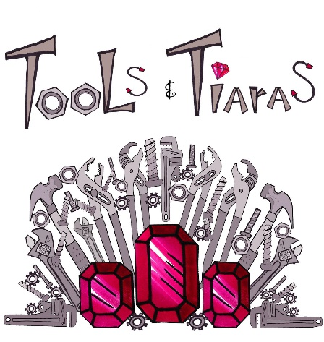 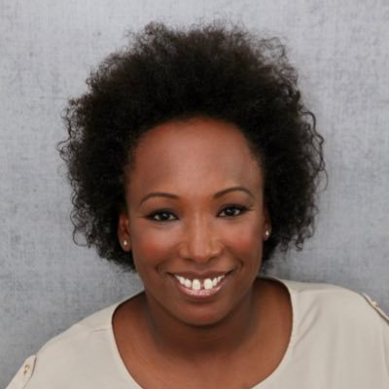

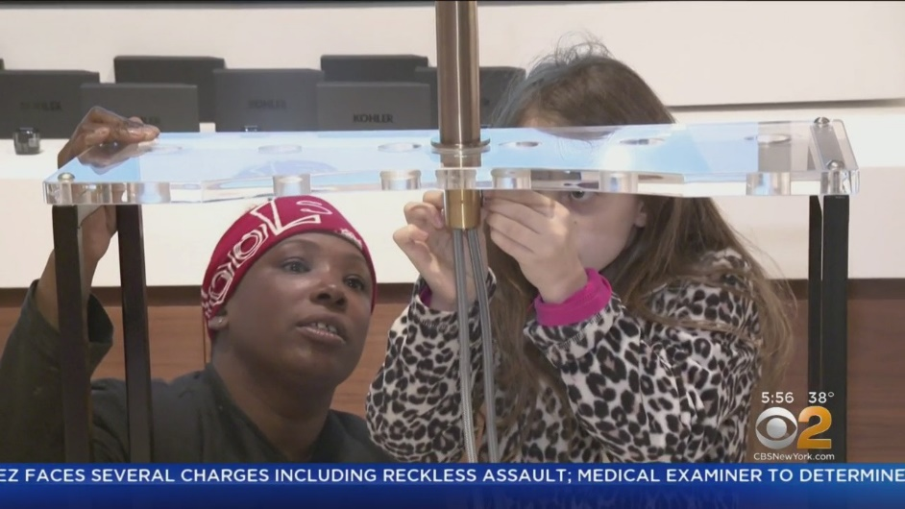

**Claire King - Pink Lady Plumbing**

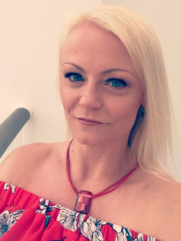 [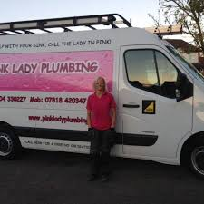](https://www.google.com/url?sa=i&rct=j&q=&esrc=s&source=images&cd=&ved=2ahUKEwiyx7O-rI_mAhXnILcAHR3qDHEQjRx6BAgBEAQ&url=https%3A%2F%2Fen-gb.facebook.com%2Fpinkladyplumbing%2F&psig=AOvVaw2te591gAE86KIlqEK10-Jn&ust=1575114353017487)

**Pink Plumbers**

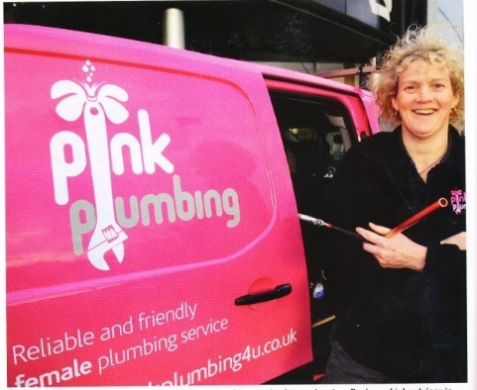 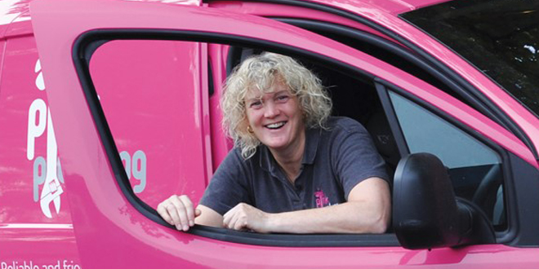

**Hattie Hasan – Stopcocks Women Plumbers**

 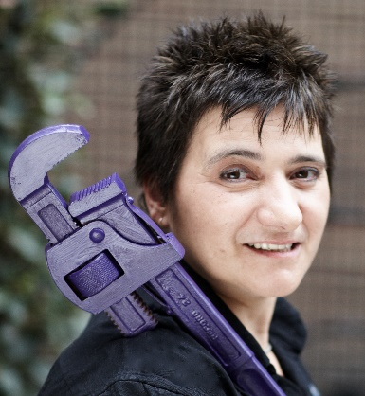 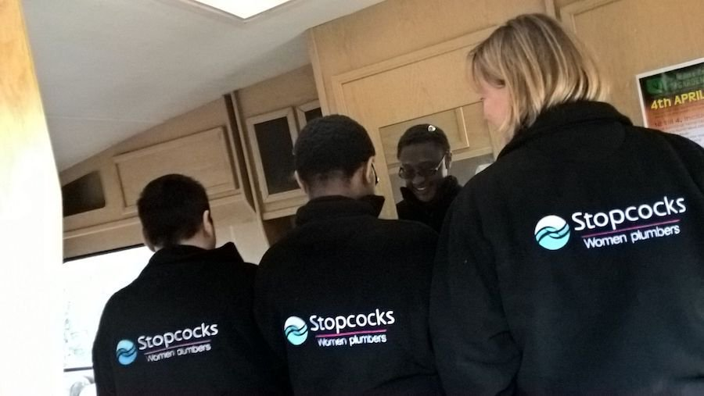

**Lauren Phillips**

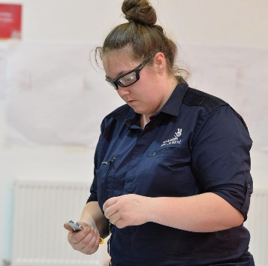 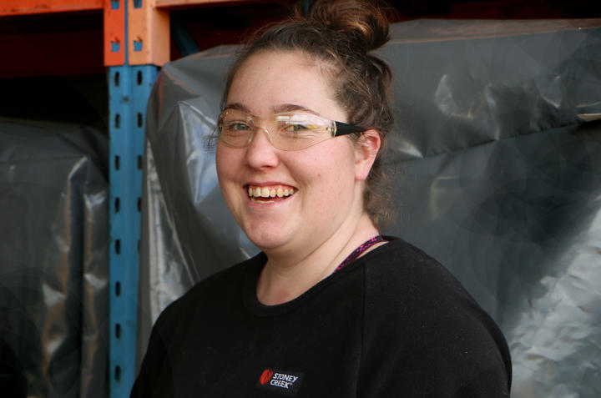 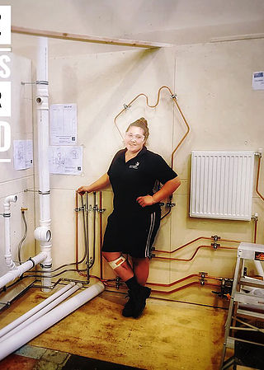

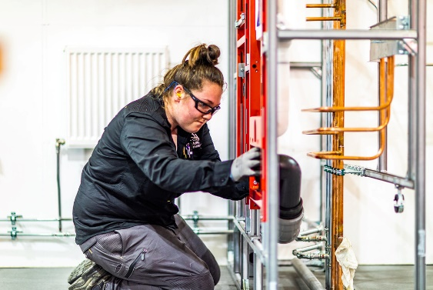

**Nasreen**

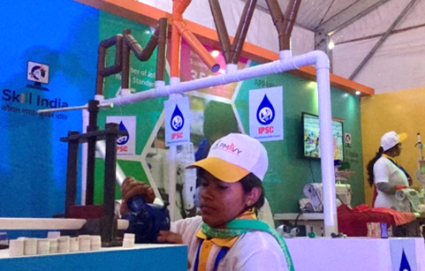

**Nirmala Nishad**

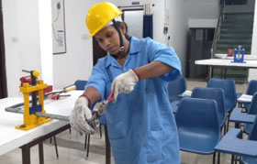 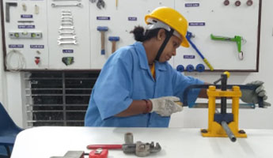

**Women Trainees**

